SWE Assignment 1

Name: Ahmed Taha

Track: PD

Case 1: (A personal insulin pump)

Product type: Generic

Application type:

1. Embedded control system

Development process model: Waterfall model

Case2: (A mental health case patient management system)

Product type: Customized

Application type:

1. Interactive transaction-based applications

Development process model: incremental model

Case3: (wilderness weather station)

Product type: Customized

Application type:

1. Interactive transaction-based applications
2. Batch processing systems

Development process model: prototype model

\*Spiral-Model:

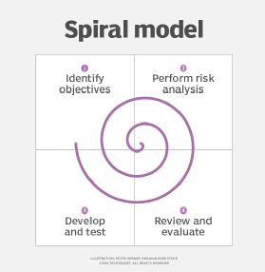

Category: plan-driven development// prototype model

How it’s used: it’s a mix between waterfall model that it has its own steps to follow but the steps are repeated in each phase not just one phase so it acts like incremental model

Benefits:

* + 1. Flexibility
    2. Risk handling
    3. Customer satisfaction

Disadvantages:

* 1. High cost
  2. Dependence on risk analysis
  3. Complexity
  4. Hard to manage time

\*V-Model:

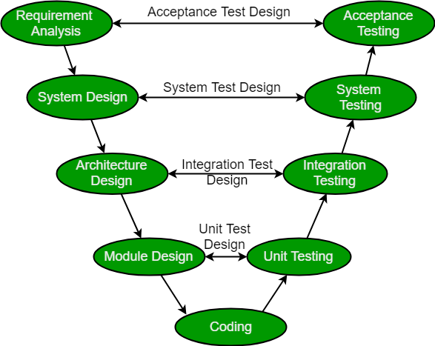

Category: plan-driven development

How it works: v-model executes in sequential manner where you perform testing on every step before going to the next one and they are connected by the coding phase to make the

V-Model

Benefits:

* 1. This is a highly disciplined model and Phases are completed one at a time
  2. V-Model is used for small projects where project requirements are clear
  3. Simple and easy to understand and use
  4. This model focuses on verification and validation activities early in the life cycle thereby enhancing the probability of building an error-free and good quality product
  5. It enables project management to track progress accurately

Disadvantages:

* 1. High risk and uncertainty
  2. It is not a good for complex and object-oriented projects
  3. It is not suitable for projects where requirements are not clear and contains high risk of changing
  4. This model does not support iteration of phases
  5. It does not easily handle concurrent events

ERP:

Enterprise resource planning is used by manufacturers to understand and manage all the

resources they need to run their business successfully

CRM:

Customer relationship management is software that manages all interactions between

customers and businesses.